The Beagle - a Healthy Breed

Beagles are medium sized, short haired dogs with no exaggerated features of conformation. They have a merry disposition and are very sociable, which makes them popular as family pets. They were originally bred to hunt hare and think for themselves. This gets them into trouble at times as they follow their noses to find food or other exciting, usually unsuitable, things to eat, often resulting in an upset digestive system. Anyone who owns a beagle needs a good sense of humour.

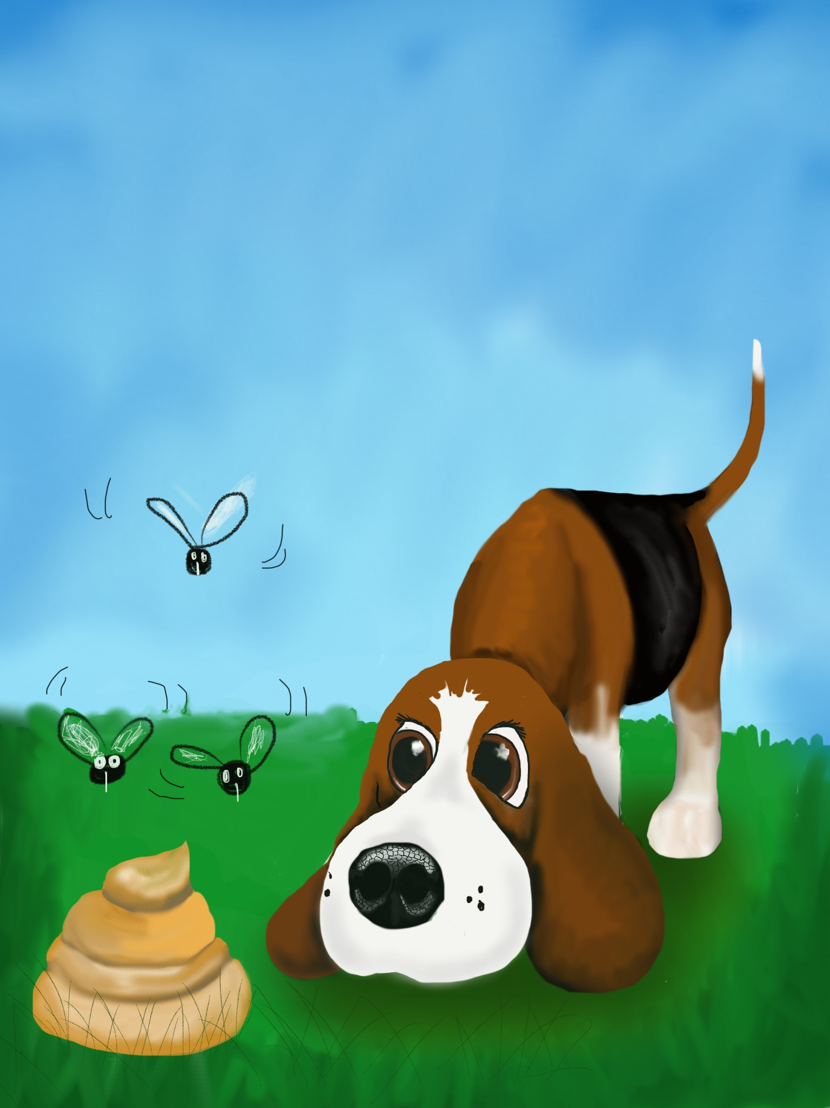
Billy has a poorly tummy. He checks out his latest poop – the 5th this morning !!!!!
Rabbit poo, dog food, and stuff out of the bin, not sure what …….

Our website www.beaglehealth.info talks about canine health in general, as well as conditions that are specific to beagles and includes discussions about the ones we feel are the most important. An internet search for beagle health matters may bring up an alarmingly long list of diseases and conditions, but the beagle is unique in being used for research and there are many thousands of papers published from this. Many of these are obscure and may relate to the laboratory population, which has become genetically selected.

Good breeders DNA test their beagles for the main conditions that may occur in pet and show beagles. This means they have done their best only to breed from healthy parents.

At the moment the four conditions most likely to be debilitating in affected beagles are MLS, NCCD, IGS and Lafora’s Disease, plus a fifth
that appears to be less of a problem: FVII deficiency. These are all
recessive conditions and are explained in more detail on the website. Briefly each dog carries two copies of the relevant genes, with one inherited from each parent. An affected beagle has two bad copies and will be affected by the condition. A carrier (one copy only) or a clear dog (no copies) cannot get the disease and will lead a normal life as far as these conditions are concerned. To avoid affected puppies, anyone breeding must know the dog’s status, as carriers of the first four can only be bred to a clear dog.

Lafora’s Disease is our newest test (released at the end of 2017) and is a slowly progressive metabolic condition, ultimately leading to neurological signs and seizures. In some ways this is one of the most important as it is not visible until the beagle is a few years old. Thus the beagle could have been bred from prior to symptoms showing. We hope all breeders will take this on board and we will have no puppies from unscreened parents in the near future.

Musladin-Lueke Syndrome (MLS) is a condition that results in several visible physical deformities as well as other issues, such as early arthritis and seizures in some cases. This was the first condition we started screening for and we now have many hereditarily clear beagles in the UK. Along with Neonatal Cerebellar Cortical Degeneration (NCCD) these have been recorded for many years and there is really no excuse for breeders not to screen for them. NCCD produces a coordination problem visible by a few weeks of age and affected beagles cannot control their hind legs properly. Both these conditions must be tested for under the UK Kennel Club Assured Breeders Scheme.

Imerslund-Grasbeck Syndrome (IGS) is caused by an inability to absorb Vitamin B12 properly. This is treatable with regular B12 injections but it is not curable. It appears to have quite a low incidence in the UK but much higher in some countries in Europe so we need to be aware of it.

FVII is one of the chemicals involved in blood clotting. Fortunately it seems to be a minor condition in most beagles, as many affected dogs have surgery without any issues. However if a dog was compromised in some way it is wise to be aware of its status.

We are also investigating epilepsy and steroid responsive meningitis (SRM) with the Animal Health Trust. We need DNA samples from affected and related beagles for this work. For more information on this and other beagle health-related matters please contact the UK the Breed Clubs’ Health Coordinator, Samantha Goldberg via samgoldberg@btinternet.com
September 2018
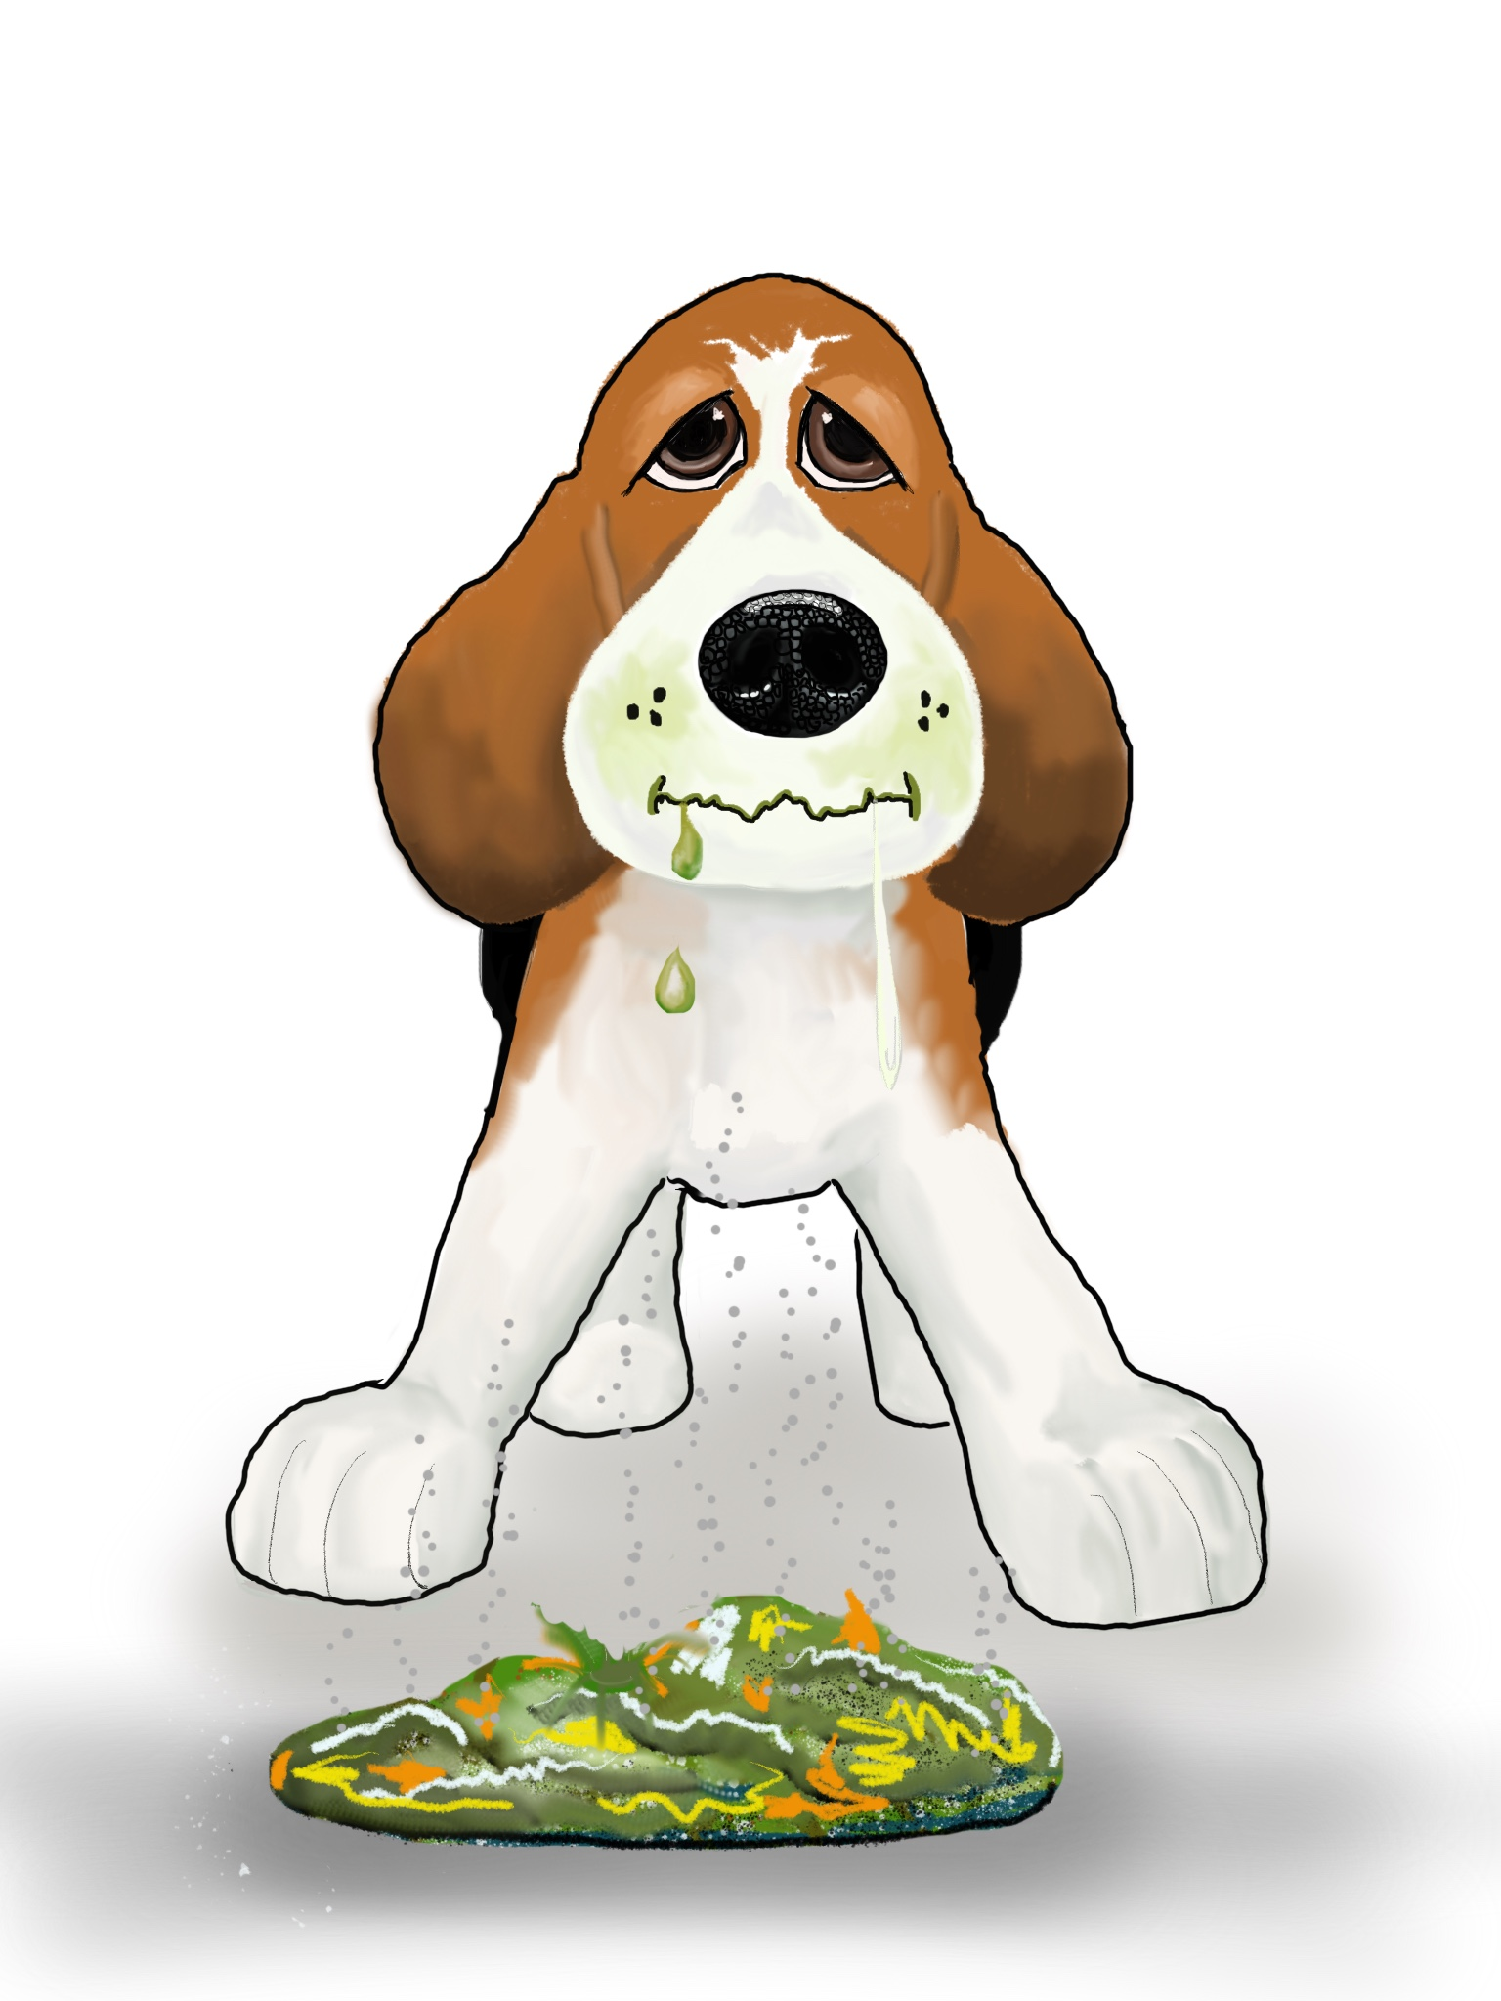
Pictures by Kath Parkin

