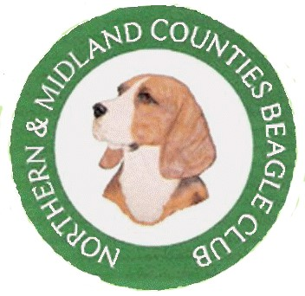
The Northern & Midland Counties Beagle Club
Application for Membership

Name(s)
Address

Tel No K.C. Affix (if applicable)

Please indicate your interest in Beagles:- (tick all that apply)
Pet Ownership |  | Showing |  | Breeding |  | Judging

I /We apply for membership of the Northern & Midland Counties Beagle Club. If this application is accepted I/we hereby agree to abide by the rules and constitution of the Club.

I/We enclose a cheque in respect of annual membership fee: -
Single Membership @ £6.00 |  | Junior Membership (under 17 years) @ £ 1.00
Joint Membership @ £8.00 |  | Overseas Membership (3 Year Term) @ £20.00
Please make cheques payable to: "The Northern & Midland Counties Beagle Club"
I/We understand that my/our election will be subject to the approval of the committee.
Signed Date
Proposed By
Seconded By
Proposer and Seconder must be members of the Club and must sign this form before it is returned to the Hon. Secretary:-
Mrs. M Walker
11 Nicholson Avenue, Barugh Green, Barnsley, South Yorkshire. S75 1NH
Please note the personal details you have provided on this form will be used by the Northern & Midland Counties Beagle Club on their membership database. The information will be stored securely by the club in line with The Northern & Midland Counties Beagle Club General Data Protection Regulations, Policy & Procedures. Full details of which are on the club’s website: www.nmcbc.net

